**Announcement and Alert Operations Guide**

Table of Contents

**Section Page**

Create New Announcement 2

Display Announcement on Website 4

Disable/Hide an Announcement 6

Archive an Announcement 7

Set Announcement to Remain Hidden Until Date 8

Set Announcement to Auto-Archive by Date 9

Delete Announcement 10

Announcements vs. Alerts 12

# Create New Announcement

1. On the Content screen, click **Add content** and select **Announcement V2**.  
     
   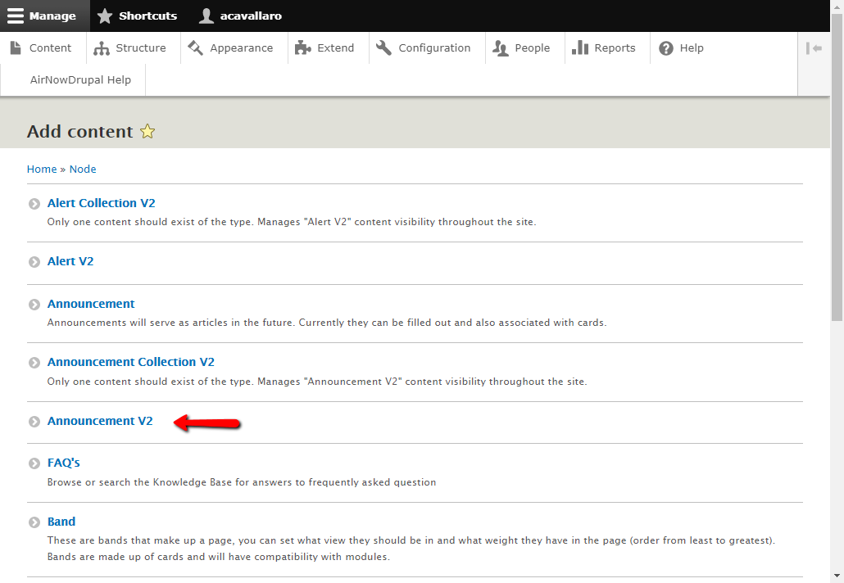
2. Enter a **Title** (use in the Content screen), **Announcement Title** (title shown on website), **Announcement Date**, **Main Text** (shown on cards, popups, and announcement pages), and **Additional Text** (only shown on announcement pages). Finish by clicking **Save**.  
     
   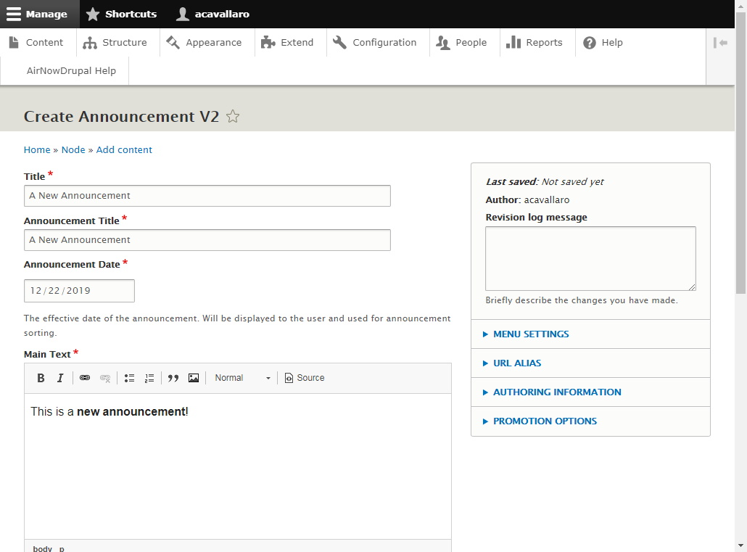  
   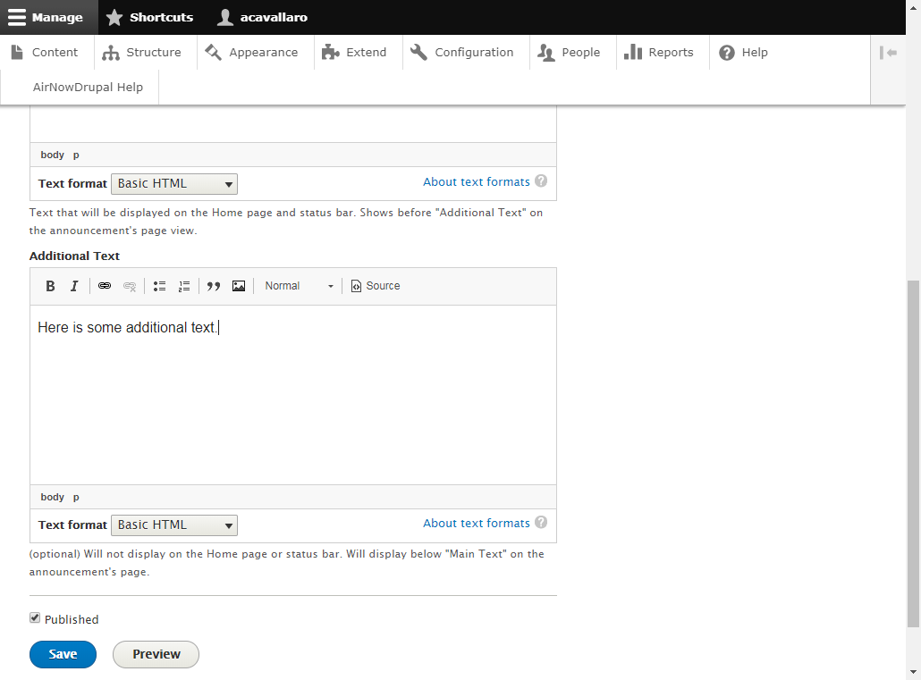

# Display Announcement on Website

1. On the Content screen, filter for content of type **Announcement Collection V2**. Click the **Edit** button for **News and Event Announcements**.  
     
   **NOTE:** There should only ever be one content with the type **Announcement Collection V2**.  
     
   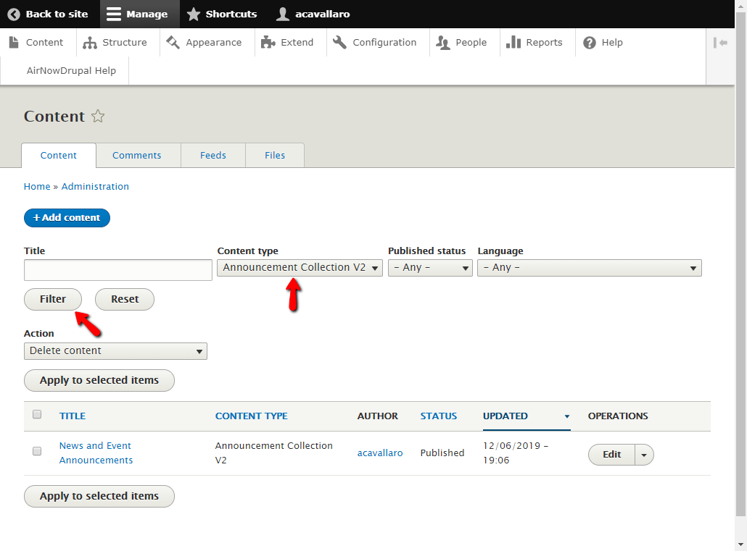
2. Scroll to the bottom of the screen and click the **Add Announcement V2 Paragraph** button.  
     
   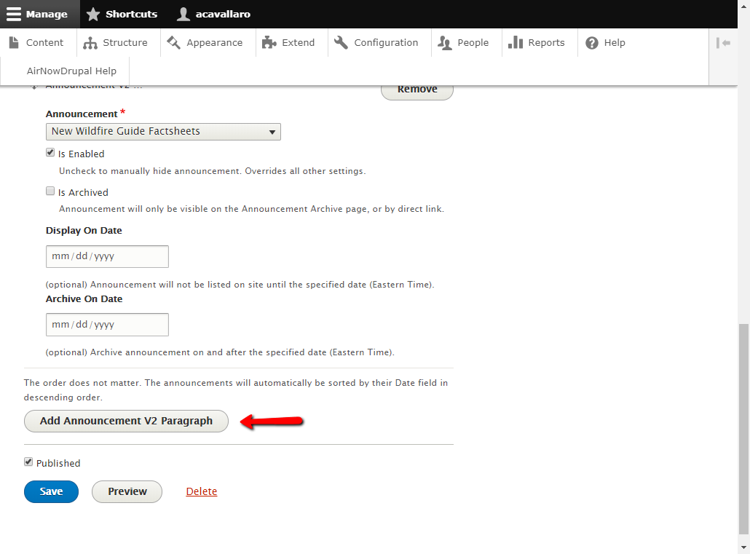
3. A new collection of fields will be added. Click the **Announcement** dropdown and select the new message, which should be at the top of the list. Assuming defaults were used for the other fields; clicking **Save** will cause the message to be displayed on the website.  
     
   **NOTE**: Drupal’s CMS cache might need to be cleared before it will show on the website.  
     
   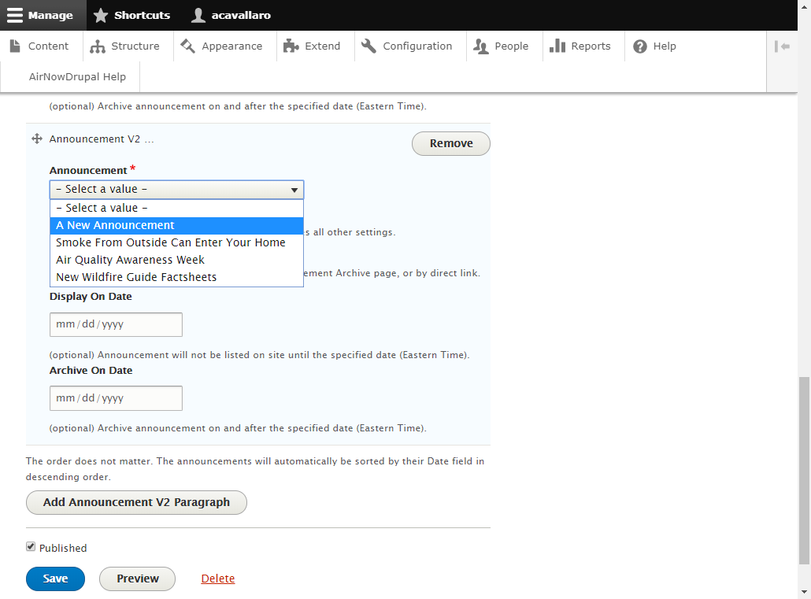

# Disable/Hide an Announcement

1. On the **News and Event Announcements** edit screen, scroll to the message you wish to hide.
2. There are two options for hiding an announcement. Either way, the announcement will be removed entirely from the website:
   1. Uncheck the **Is Enabled** box.
   2. Click the **Remove** button.

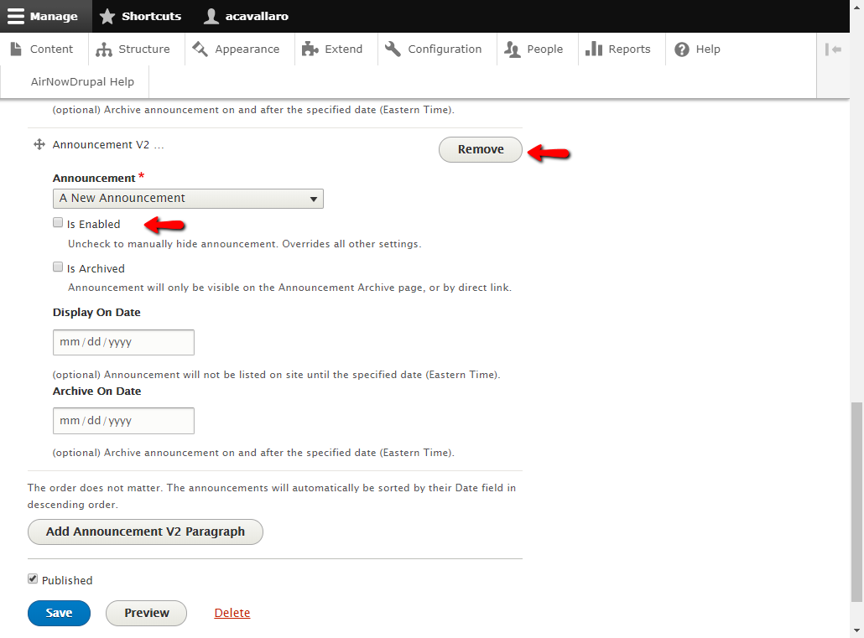

# Archive an Announcement

1. On the **News and Event Announcements** edit screen, scroll to the message you wish to archive.
2. Check the **Is Archived** box and click **Save**. The message will no longer show on the popup or dial page. It will only be visible either by direct link, or the **/announcements** website page.  
     
   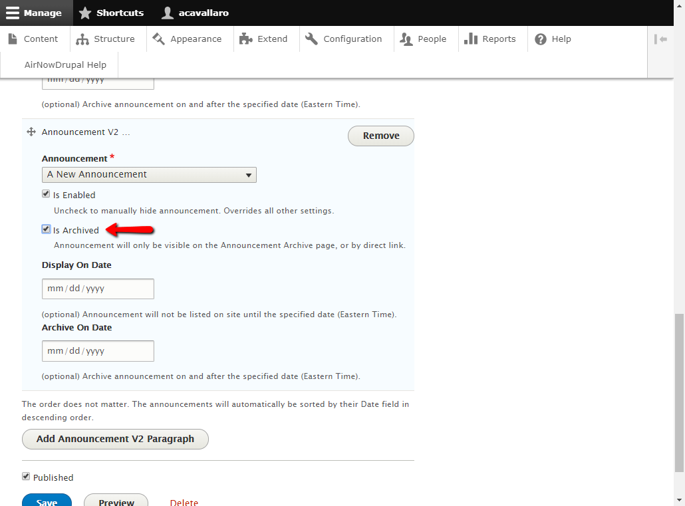

# Set Announcement to Remain Hidden Until Date

1. On the **News and Event Announcements** edit screen, On the News and Event Announcements edit screen, scroll to the announcement you wish to modify.
2. Set the **Display On Date** field to the date you wish for the announcement to be automatically shown on the website and click **Save**.  
     
   On that date (Eastern Time), the message will become visible on the popups, dial page, and **/announcements** page.  
     
   **NOTE:** This field is ignored if **Is Enabled** is unchecked.  
     
   **NOTE 2:** This field can be used alongside **Archive On Date**, just be mindful of the dates used.  
     
   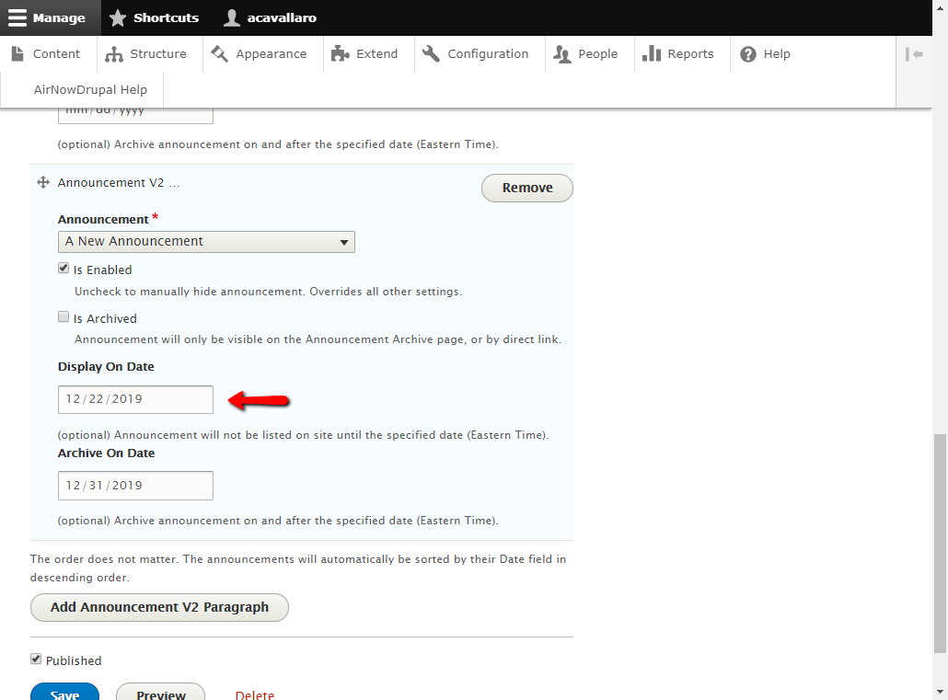

# Set Announcement to Auto-Archive by Date

1. On the **News and Event Announcements** edit screen, scroll to the announcement you wish to modify.
2. Set the **Archive On Date** field to the date you wish for the announcement to be automatically archived and click **Save**.  
     
   On that date (Eastern Time), the message will only be visible on the **/announcements** page or by direct links.  
     
   **NOTE:** This setting is ignored if **Is Archived** is checked, or **Is Enabled** is unchecked.  
     
   **NOTE 2:** This field can be used alongside **Display On Date**, just be mindful of the dates used.  
     
   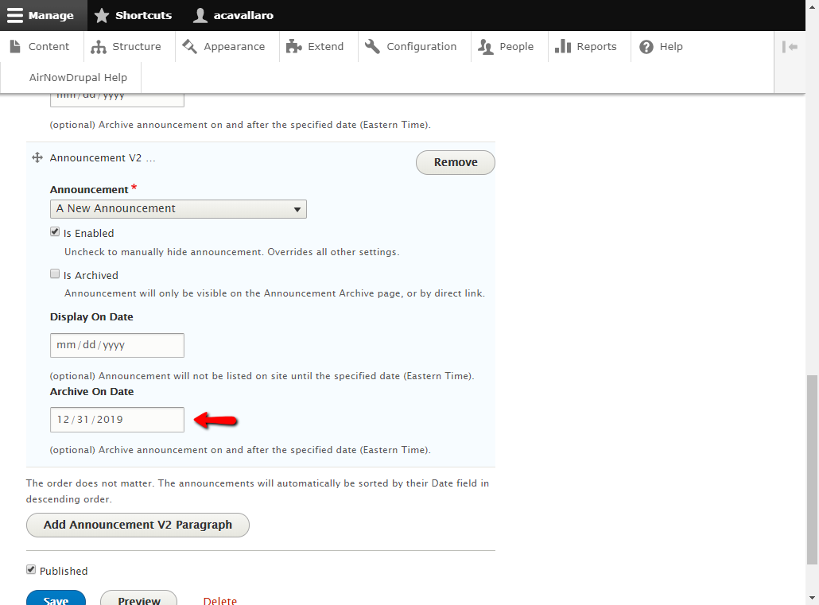

# Delete Announcement

1. **WARNING**: Do not delete an announcement from the **Content** screen if it is currently referenced by **News and Event Announcements**. This may cause an error to show on the website.
2. Instead, first go to the **News and Event Announcements** edit screen and search for the announcement you wish to remove. If found, click the **Remove** button and then **Save**.  
     
   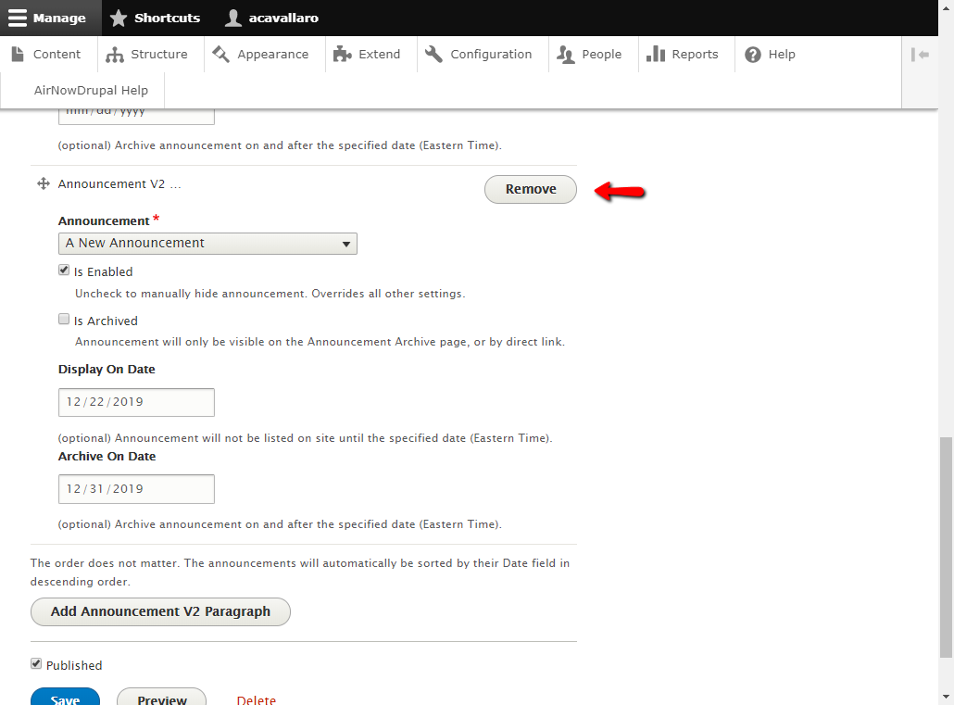
3. It is now safe to delete the announcement from the Content screen.  
     
   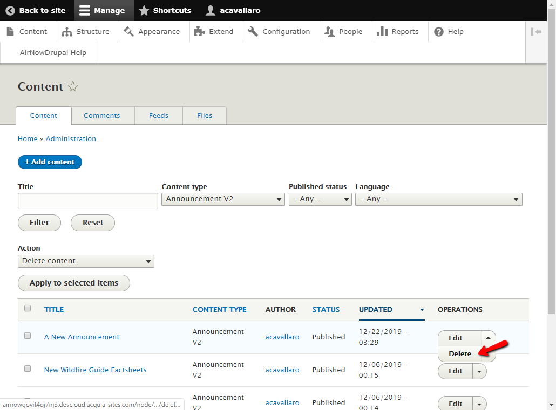

# Announcements vs. Alerts

* Functionally, Announcements and Alerts are structured the same way. The method to create and customize them is currently identical.
* The reason for the separation is to make it easier to track which alert/announcement is displayed where on the site. Also, this gives us the ability to independently change their functionality in the future.
* Announcements are of the content type **Announcement V2**, while alerts are of the content type **Alert V2**. They both have the same fields, and have the similar setup for displaying on the website. You can use the same instructions outlined earlier in this document for setting up an **Alert V2** alert.
* The content **News and Event Announcements** (of type **Announcement Collection V2**) manages announcements, while the content **System Alerts** (of type **Alert Collection V2**) manages alerts. You can use the same instructions outlined earlier in this document for associating alerts with the **System Alerts,** and thus the website.
* Announcements will show on the dial page cards, popups and **/announcements** page. While Alerts will show on their own popups and **/alerts** page (but not the dial page cards).